Wikumkewi’kus

September 2022 Newsletter
Natoaganeg School
11 Riverview Road East
Eel Ground N.B.
E1V-4G1
Terri Anne Larry, Principal Phone (506) 627-4615
Jenny Sonier, Vice Principal Fax (506) 627-8597

Dear Families & Caregivers:
We hope everyone enjoyed the Summer Holiday.
Attached to this newsletter are registration forms, please ensure all forms are filled out and returned to the school as soon as possible. It is very important that the school has the most up to date information for students. Phone numbers and address changes must be reported to school administration as it is imperative that staff have reliable information so they can communicate with parents/guardians.

Important Dates

September 29
1/2 Day for Students
Orange Shirt Day Walk (AM)
No school for Students (PM)

September 30
School Closed in recognition of Treaty Day

October 10
Thanksgiving Day - Holiday

Orange T-shirt Day September 29th

Natoaganeg school staff and students will be participating by wearing orange t-shirts and walking in support of residential school survivors and the principle that every child matters.
www.orangeshirtday.org
The events were designed to commemorate the residential school experience, to witness and honor the healing journey of the survivors and their families. To commit to the ongoing process of reconciliation.
Orange T-Shirt Day is an opportunity for First Nations, local governments, schools and communities to come together in the spirit of reconciliation and hope for generations of children to come.

Kelulk Mijipjewey - We Eat Good Food
At Natoaganeg School we do our best to impart a message to the students that promotes healthy foods and healthy food choices.
One way we do this is by providing the children with a healthy and nutritious breakfast, mid-morning snack and lunch each day.
If children bring a snack or lunch from home, they should come prepared with a healthy choice that is low in sugar and sodium.
Some examples of an appropriate snack are: applesauce, fruits, veggies, cereal bar, granola, yogurt, and cheese.
Chips, candy and chocolate should not be brought to school.
Menu items are subject to change due to supply availability.
Mi’kmaq Monday

An initiative at our school is Mi’kmaq Monday.
Every Monday we will have a smudge in the drum of the school to start the week and encourage students and staff to wear something of cultural importance to them such as braided hair, beaded items, culturally positive clothing, moccasins, etc...
We want our students to be proud of their cultural identity and we are looking forward to implementing any other cultural initiatives or ideas they have!

PATHS® IN OUR SCHOOL
Parents…do your children ever have difficulty calming down?
You can use the control signals poster as a way to help your child get control of their behavior.
Step 1 is the Red Light: STOP! Take a long, deep breath. Say the problem and how you feel.
Step 2 is the Yellow Light: THINK! What can I do? Would it work?
Step 3 is the Green Light: GO! Try out your solution. Your child is learning this way to solve problems in the classroom during our PATHS® lessons. Using the same steps at home will help your child remember and follow these steps more often when they have a problem. Helping your child solve their own problems builds self-esteem!
Natoaganeg School Staff 2022 2023
K4
Grade 5
Teacher Mikayla Connors
EA Tasha Hachey
Grade 6
Teacher Serena Harris
EA Nicole Matchett
EA Ev Gray
Grade 7/8
Teacher Joseph Canistro
EA Micaela Hachey
Brianna Hubbard

Principal: Terri Anne Larry
Math Lead: Hillary Manuel
Literacy Lead & Resource: Jenny Sonier
Phys. Ed and Health: Robbie Ross
Culture: Natalie Larry
Mi’kmaq Resource: Freda Simon
Guidance: Cathy Hyland
Admin Assistant Lacey Lynch Larry and Lana Joss
Head Cook Stacey McCormack
Custodian Joe Simonson
SEL, PATHS® D2L Lead Emily Case
Resource Assistant Melanie Duplessis

Teacher Sarah Wiltshire
EA Jackie White
EA Ky Martin
K5/Grade1
Teacher Jennifer MacEachern
EA Justine Larry
EA Sylvia Miller
EA Bailey Trevors
EA Lacey Creamer
Grade 2
Teacher Amelia Bruce
EA Emma Ward
EA June Augustine
EA Tami Michaud
Grade 3/4
Teacher Layne Wallace
EA Brooke Trevors
EA Emma Gillespie
EA Melissa Colford

School Schedule
8:10- 8:35am Breakfast is served
There is always a hot breakfast option along with fresh fruit, a toasted item such as bagel, toast or english muffin and cereal.
8:40am Morning announcements
8:45am Classes begin
10:15-10:30am Nutrition Break
Students are provided with a healthy snack option, if they choose to bring a snack from home, please ensure it is low in sugar and sodium.
11:40am-12pm K4 – Gr 3/4 Lunch
12-12:20pm Gr.4/5 – Gr.8 Lunch
2 pm K4 – Gr.2 Dismissal
2:30pm Gr.3/4 – Gr.8 Dismissal

SUCCESSFUL NEWSLETTER DELIVERY BALLOT
Sign below to indicate that your student has delivered to you this month’s newsletter. Have your child return this ballot to the ballot box located at the school office by Friday, September 24th. At the end of the month, a draw will be made for a gift certificate from all the ballots that are returned.

__________________________________________________________________________________________
Student name. Grade Parent/Caregiver Signature

Back-to-School Sleep Tips for Kids

Best case scenario is that you and your child(ren) have been working on changing their sleep habits slowly over the past couple of weeks. It not, no worries…start today!!
Mention the word “bedtime” in the summer and you’re sure to hear groans from your kids — especially if they’ve spent the last few months staying up late and sleeping until noon.
When it’s time to go back to school, though, getting back into healthy sleep patterns is a necessity for having the right amount of focus and energy in the classroom.
How much sleep does my child need?
Kids need more sleep than grown-ups do.
Children ages 5-12: recommend 9-12 hours of sleep
Teenagers: 8-10 hours of sleep

1. Don’t make the transition overnight
Hopefully, tomorrow isn’t the first day of school! If you still have a couple weeks until that morning bell rings, it’s time to work on transitioning your kids’ bedtime and wake-up time.
Transitioning kids’ sleep schedules too quickly can cause sleep deprivation, which can, in turn, lead to in-school sleepiness, decreased attention span, poor academic and sports performances, and more.
2. Go 15 minutes at a time
Here’s another reason to start in advance: It could take a while. “Adjusting your kids’ wake-up time by two hours could take one to two weeks,” Dr. Shah says, “so it’s not a good idea to wait until the day before school starts to make changes.”
A few weeks before school begins, start shifting your kids’ wake time earlier by 15 minutes every two to three days. Then, calculate the correct bedtime based on the amount of sleep they need.
3. Wind down an hour before bedtime
In the summer, kids may stay up late and pass out exhausted after long, fun, sun-soaked days. During the school year, though, it’s important to stick to more consistent bedtime/wake-up routines.
Start unwinding before kids even climb into bed. “The last one hour before bedtime should be relatively quiet and calming,” Dr. Shah advises. That means no exercise, no caffeine, no TV and no cell phones.
4. Provide optimal sleeping conditions
Darkness signals to kids’ bodies that it’s time to sleep. It also allows their natural melatonin levels to rise, which helps them fall (and stay) asleep. In the early weeks of the school year, though, the sun may still be up when their bedtime approaches.
To mimic nighttime, use heavy drapes that darken your child’s bedroom. “A dark, quiet and somewhat cool room can help kids fall asleep at the right time,” Dr. Chen notes.
5. No sleep aids for kids
You may be accustomed to taking melatonin before bed or using a light therapy lamp in the morning. But what works for adults isn’t always recommended for kids. While these tools can help children who have significant sleep issues, they should only be used under a doctor’s supervision.
can make kids’ sleep issues much more complicated than they have to be.”

Adapted from: https://health.clevelandclinic.org/back-to-school-means-back-to-bedtime/

World Suicide Prevention Day
-a time to connect and reflect
Every year on September 10th, people in over 50 countries recognize #WSPD
World Suicide Prevention Day is a chance for everyone to join us in promoting understanding about suicide: and those impacted by a suicide attempt or loss.
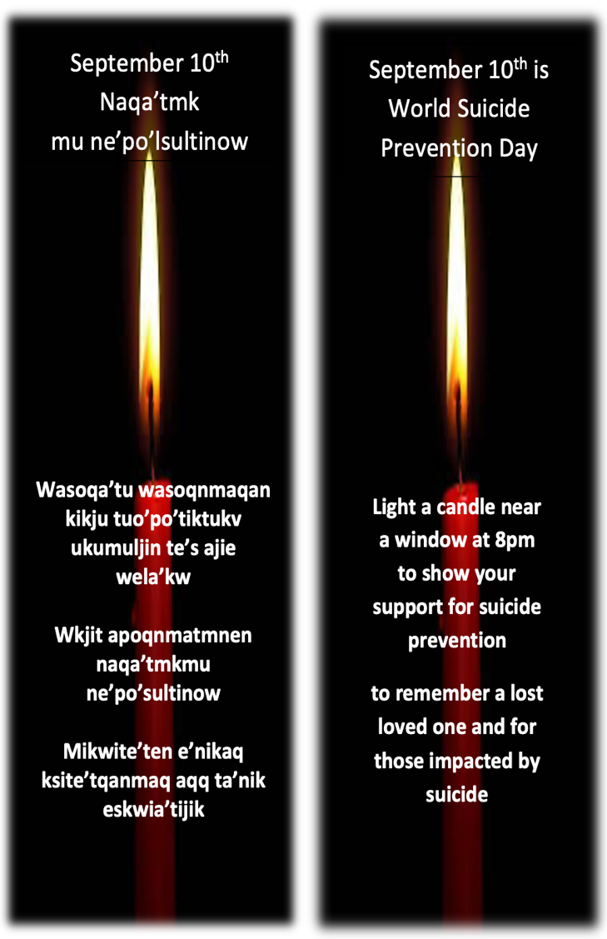
This week, every student will receive a flameless votive.

Adapted from: https://suicideprevention.ca/

