|  |
| --- |
| Natoaganeg School  11 Riverview Road East  Eel Ground N.B.  E1V-4G1  Terri Anne Larry, Principal Phone (506) 627-4615  Jenny Sonier, Vice Principal Fax (506)627-8597 |
| Wikumkewiku’s Newsletter September 2024  Dear Parents / Guardians:  **In recognition of National Day for Truth and Reconciliation and Treaty Day Natoaganeg School will be closed on September 30th and October 1st**    September 30th has been declared National Day of Reconciliation or Orange Shirt Day in recognition of the harm the residential school system caused children's sense of self-esteem and well-being, and as an affirmation of our commitment to ensure that everyone around us matters.  In response to the Truth and Reconciliation Commission’s 94 Calls to Action, September 30th has been designated as National Day of Reconciliation and is a holiday for staff and students at Natoaganeg School. This Day of Reconciliation is an opportunity to reflect, commemorate and acknowledge the impact and history of  residential schools.    On Friday, September 27 at 10:30am students and staff from Natoaganeg school will be holding a gathering to remember the children who did not come home from Indian Residential schools, to support the families who have suffered the loss of their children and to honor those who survived. We will wear our orange shirts as we gather for smudge, prayer and a walk throughout the community. |

**September is Suicide Awareness and Prevention Month**

**As we work together as a caring and loving community, we are reminded that we can all have a role in helping/guiding/supporting someone who is struggling with thoughts of suicide or are dealing with loss from suicide. Small actions can have a huge impact. When someone is struggling...**

**Eagle Feather logo | Feather clip art, Native american eagle feather  tattoo, Eagle feather tattoos Check in with them regularly to see how they are doing**

**Eagle Feather logo | Feather clip art, Native american eagle feather  tattoo, Eagle feather tattoos** **Listen supportively to what they have to say**

**Eagle Feather logo | Feather clip art, Native american eagle feather  tattoo, Eagle feather tattoos** **Remember that you don’t have to have all the answers**

**Eagle Feather logo | Feather clip art, Native american eagle feather  tattoo, Eagle feather tattoos** **Know and introduce them to resources in their area, if they need additional support**

**Eagle Feather logo | Feather clip art, Native american eagle feather  tattoo, Eagle feather tattoos** **Be prepared to assist them in finding information, but don’t take over**

**On September 10th, every student and staff at Natoaganeg School will receive a laminated bookmark and a flameless votive.**

**The bookmark has a message of light and hope in Mi’kmaq and English. The message and the light from the candle is a reminder of the hope and strength that we bring to each other and the courage to reach out without judgement or shame.**



Light a candle near

a window at 8pm

to show your

support for suicide

prevention

to remember a lost

loved one and for

those impacted by

suicide

September 10

th

Naqa’tmk

mu Ne’po’lsultinew

Se

ptember 10

th

is

World Suicide

Prevention Day



Waso

qa’

tu

wasoq

nmaqan

kikju

tuopitiktuk

ukumuljin te’s ajiet

wela’kw

Wkjit apoqnmatmenen

naqa’tmk mu

ne

’po’sultinew

Mikwite’ten e’nikaq

ksite’tqanmaq aqq ta’nik

eskwi

a

’tijik

.

Kelulk Mijipjewey - We eat good food

At Natoaganeg School we do our best to impart a message to the students that promotes healthy foods and healthy food choices.

One way we do this is by providing the children with a healthy and nutritious breakfast, mid-morning snack and lunch each day.

If children bring a snack or lunch from home, they should come with a healthy choice that is low in sugar and sodium.

Some examples of an appropriate snack are:

applesauce, fruits, veggies, cereal bar, granola, yogurt, cheese, crackers.

Sugary snacks & drinks, chocolate, and chips should not be brought to school.



**Mi’kmaq Monday**

An initiative we have been doing in our school is Mi’kmaq Monday.

Every Monday we will have a smudge in the drum of the school to start the week and encourage students and staff to wear something of cultural importance to them such as braided hair, beaded items, culturally positive clothing, moccasins, etc.

We want our students to reclaim their cultural identity and we are looking forward to implementing any other cultural initiatives or ideas they hav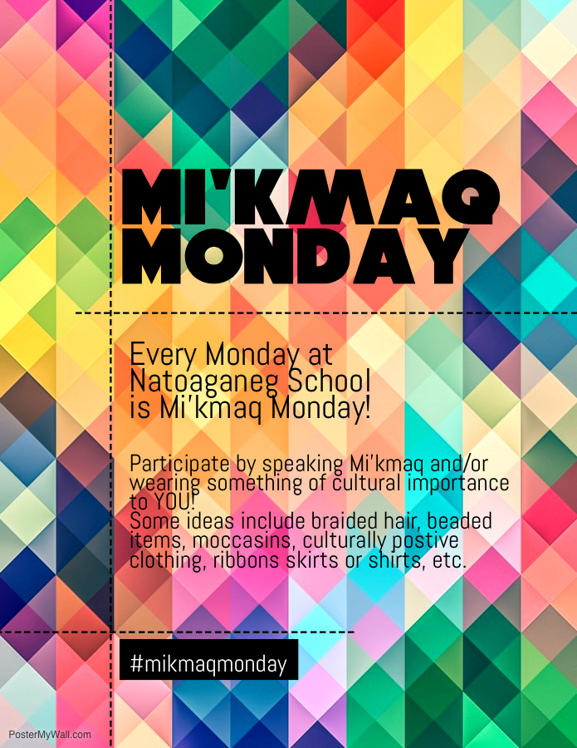e.

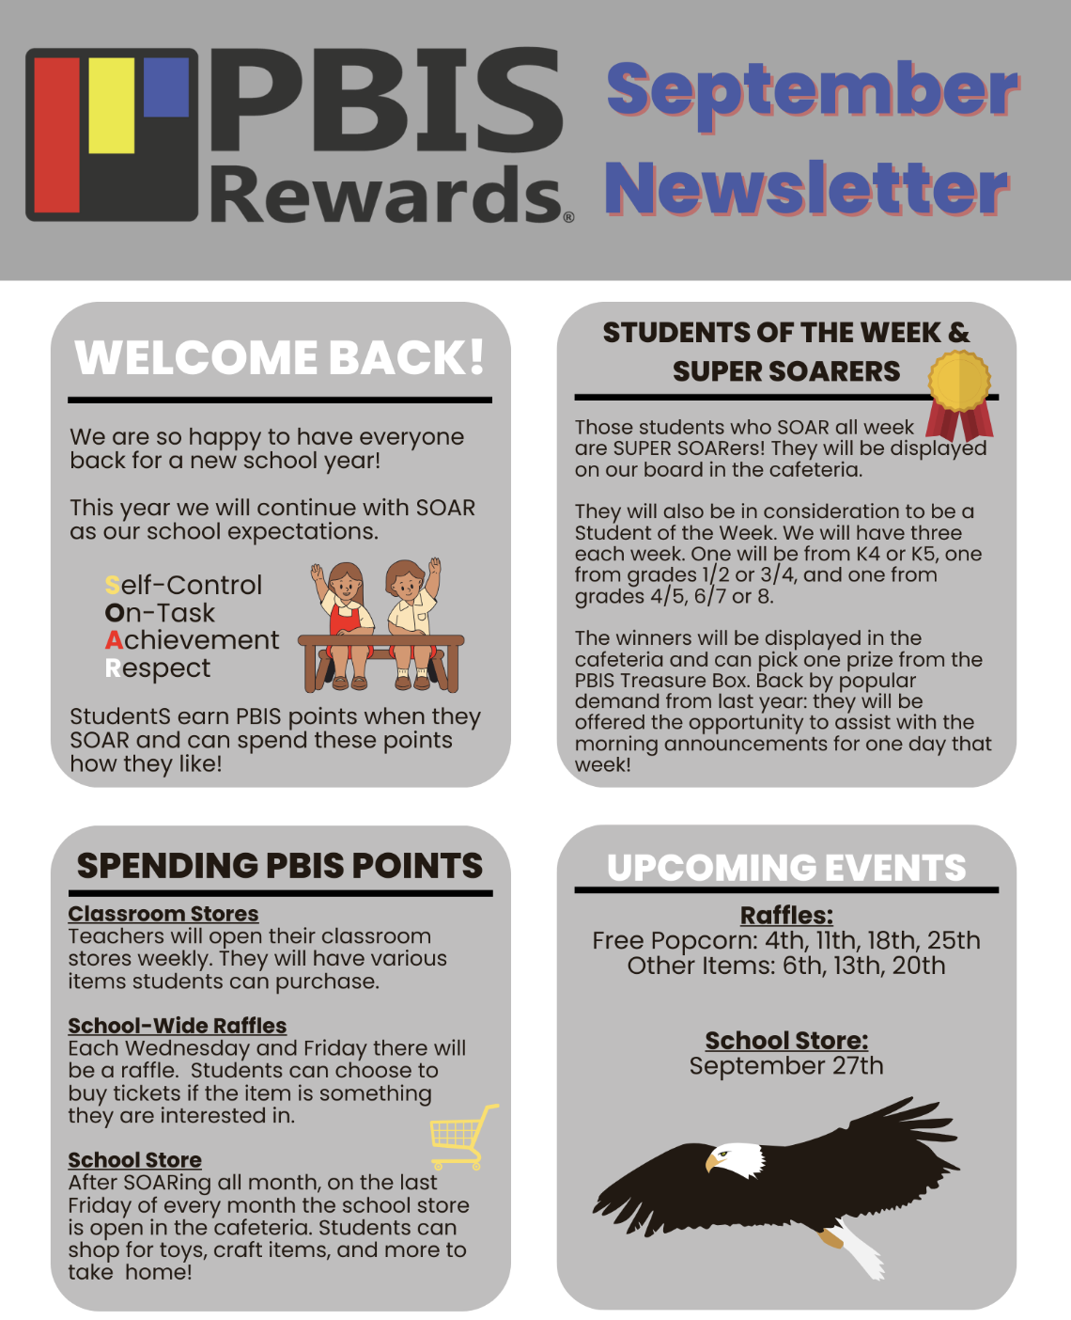

**School Schedule**

8:10- 8:30am Breakfast is served

There is always a hot breakfast option along with fresh fruit, a toasted item such as bagel, toast or english muffin and cereal.

8:40 am Morning announcements

8:45 am Classes begin

10:15-10:30am Nutrition Break

Students are provided with a healthy snack option, if they choose to bring a snack from home, please ensure it is low in sugar and sodium.

12-12:20 pm K4 – Gr 3/4 Lunch

12:20-12:40pm Gr.4/5 – Gr.8 Lunch

2:30 pm K4 Gr.8 Dismissal

**SUCCESSFUL NEWSLETTER DELIVERY BALLOT**

Sign below to indicate that your son/daughter has delivered to you this month’s newsletter. Have your child return this ballot to the ballot box located at the school office by Friday, September 24th. At the end of the month, a draw will be made for a gift certificate from all the ballots that are returned.

_____________________________________________________________________________________________

Student Name Grade Parent Signture