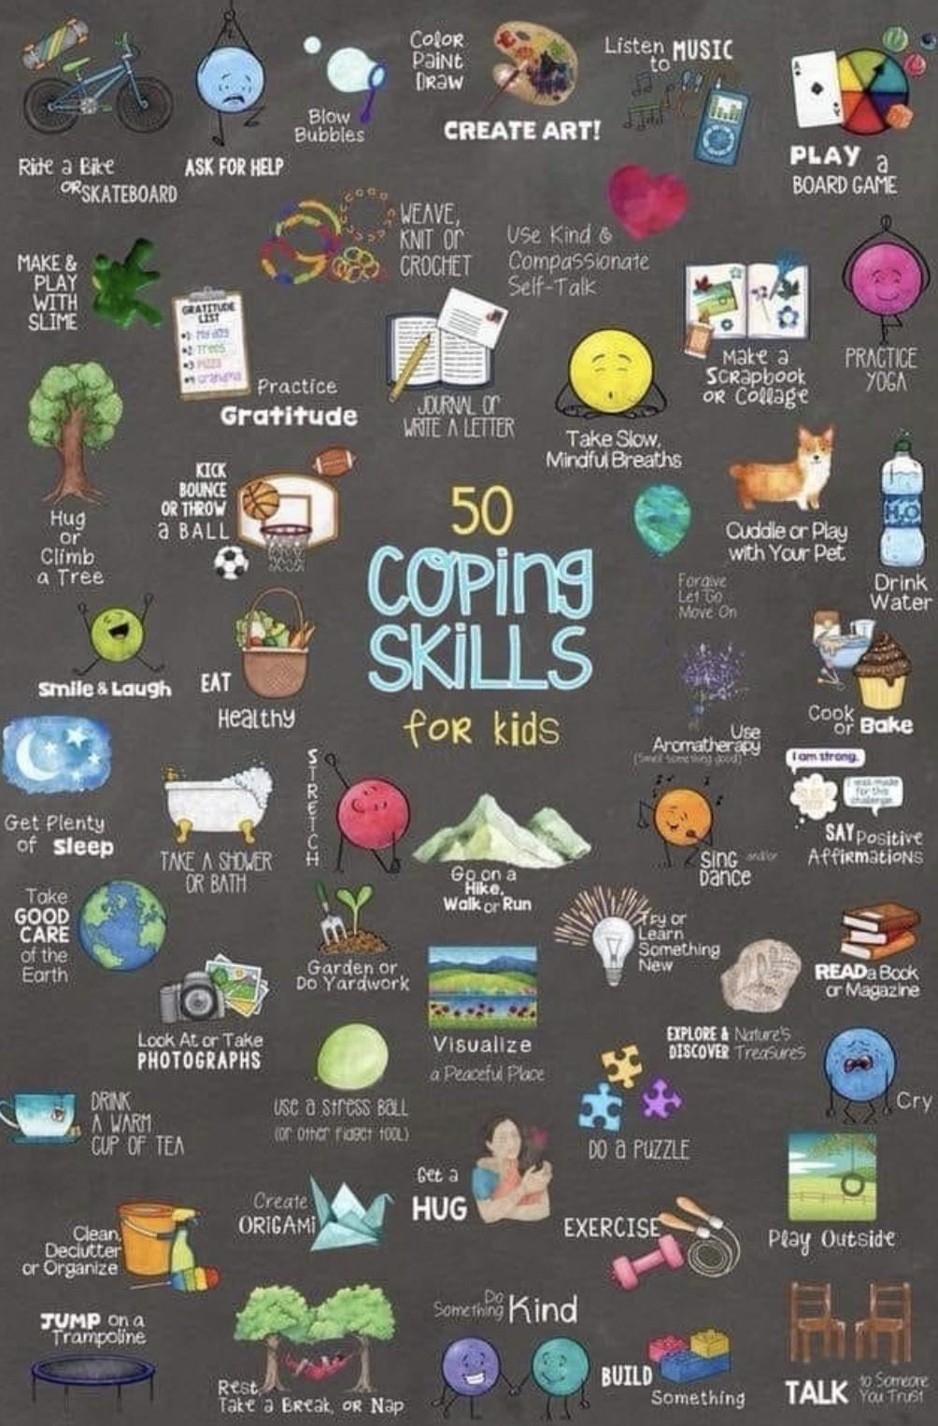

Thank You to everyone that supported the Cookie Dough Fundraiser. We raised close to $2000.00 for our school. The funds will be used for afterschool activities and end of the year trips.

We would like to give special recognition to William Harris who had over $800 in sales.

We expect the order to arrive on November 10th.

The order will be ready for pickup in the front entrance of the school after lunch.

Keptekewiku’s November 2020

Macintosh HD:Users:Reception:Desktop:remembrance clipart 5.jpg

There will be no school on Wednesday November 11 in recognition of Remembrance Day.



**Dear Parents/Guardians:**

Please read through the newsletter so that you are informed of what is up and coming at our school.

We have a new Breakfast and Lunch Menu. Please go over it with your child and if there is something they do not want to eat, please send an appropriate lunch with them. Students have access to the microwave but food must be precooked and be able to be reheated in the 2 minutes or less.

Please do not sent chips, candy, chocolate or foods high in sodium to school.

Natoaganeg School

11 Riverview Road East

Eel Ground N.B.

E1V-4G1

Terri Anne Larry, Principal Phone (506) 627-4615

Fax (506) 627-4621

*Students in grades 3 to 8 are required to bring a change of clothes for gym class. All students must have an appropriate pair of indoor shoes that can be left at school.

\***Please ensure your child is dressed appropriately for the weather as it is getting colder and the students go outside for recess at lunch.**

**It is important that the school has the most up to date phone numbers for our students. If you have changed your phone number or the emergency contacts have changed, please notify the school of these changes.**

**SUCCESSFUL NEWSLETTER DELIVERY BALLOT**

Sign below to indicate that your son/daughter has delivered to you this month’s newsletter. Have your child return this ballot to the ballot box located at the school office by Friday, November 27 2020. At the end of the month a draw will be made for a gift certificate from all the ballots that are returned.

Winner for October: Charley W.

_______________________________________________________________________________

Parents Signature Child’s name Grade

**Important reminders**

Nov.11 Remembrance Day - All Schools closed

Nov.20 PD Day - No School for students

Dec.2 Report Cards go home

Dec.4 Parent Teacher – No school for students

**Schedule**

Breakfast served 8:20 – 8:45am

Classes begin 8:45 am

**Lunch:**

K4-Gr.2 11:40 – 12pm

Gr.3-5 12 – 12:20pm

Gr.6-7 12:20 – 12:40pm

**Dismissal:**

K4-Gr. 2 2:00 pm

Gr.3-8 2:30 pm

**Attendance Policy**

School attendance is taken at 8:45am. Breakfast is served from 8:20 – 8:45 am. Student’s that are walking should arrive as close to 8:30am as possible (especially if they are eating breakfast)*.*

- sodales.

**Jukuey tog**

**Come here then.**

**Tami wigin?**

**Where do you live?**

Koqwey kesnu’kuask

What’s ailing you?

Mi’kmaq Word of the Day

**Mental Wellness Check In**



Follow us:

Website [www.eelgroundschool.ca](http://www.eelgroundschool.ca)

**Breakfast with Santa**

**Saturday, November 28th 2020**

Take out only.

More information will be posted

as soon as it is available.

Facebook page/group:

Natoaganeg School

**Paths® in our School**

Solving problems is hard for children. Solving problems as a group is a skill that our students work on during PATHS**®** time. We learn to identify the problem and write it down. We talk about how we feel about the problem. Then, we brainstorm as many solutions to the problem as we can. We act out the best choices to see how they might work. Next, we choose the best solution and all agree to try it for a few days. We agree to come back and see if we have solved the problem or if it is still happening. If we still have a problem, we try these steps again. We keep trying to solve problems as a group, because we care about each other and work together to be a successful school! You can try this way to solve family problems too. Together is better!

Issue | Date

Lorem Ipsum