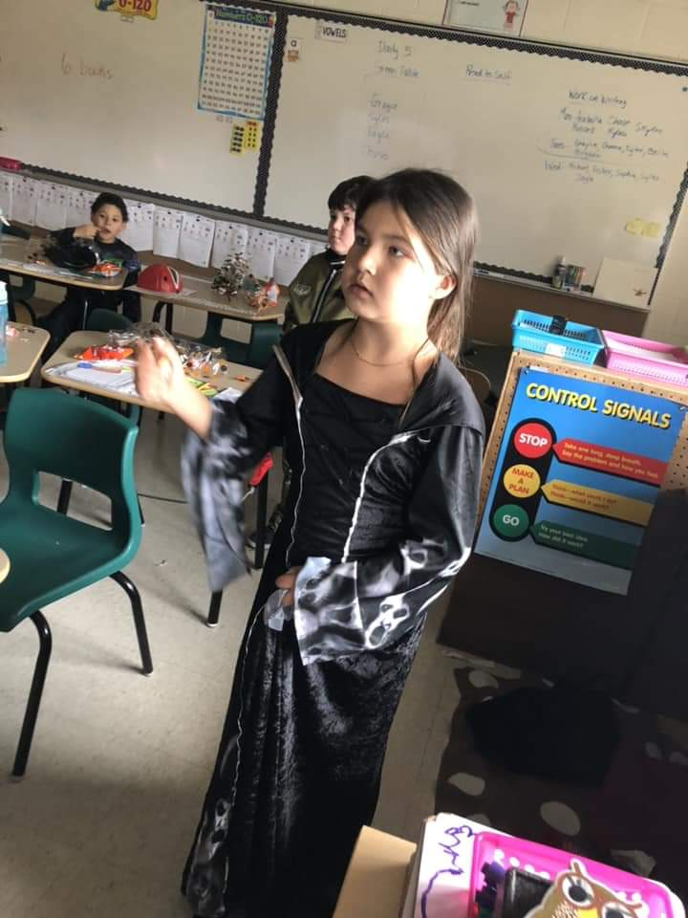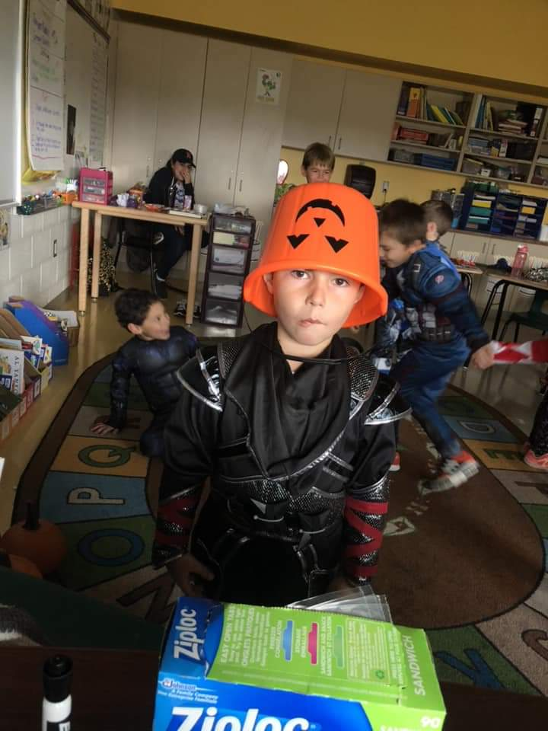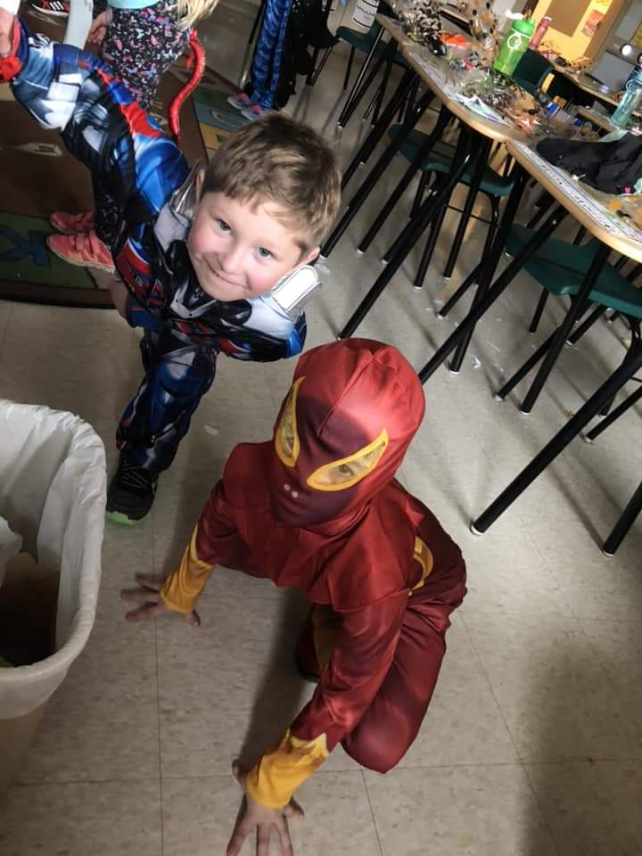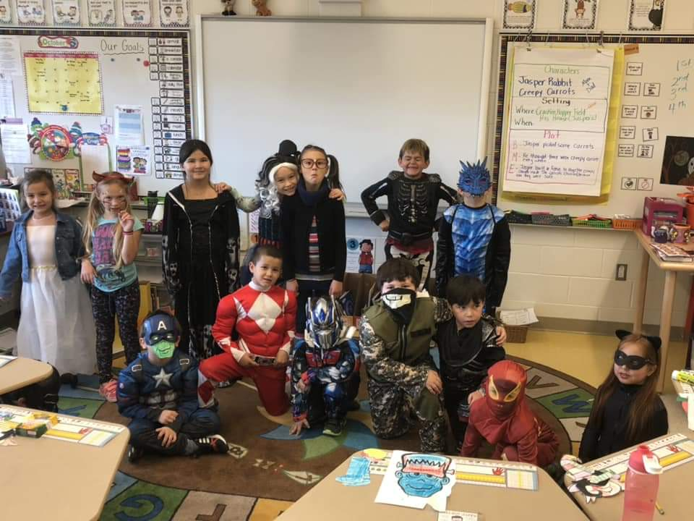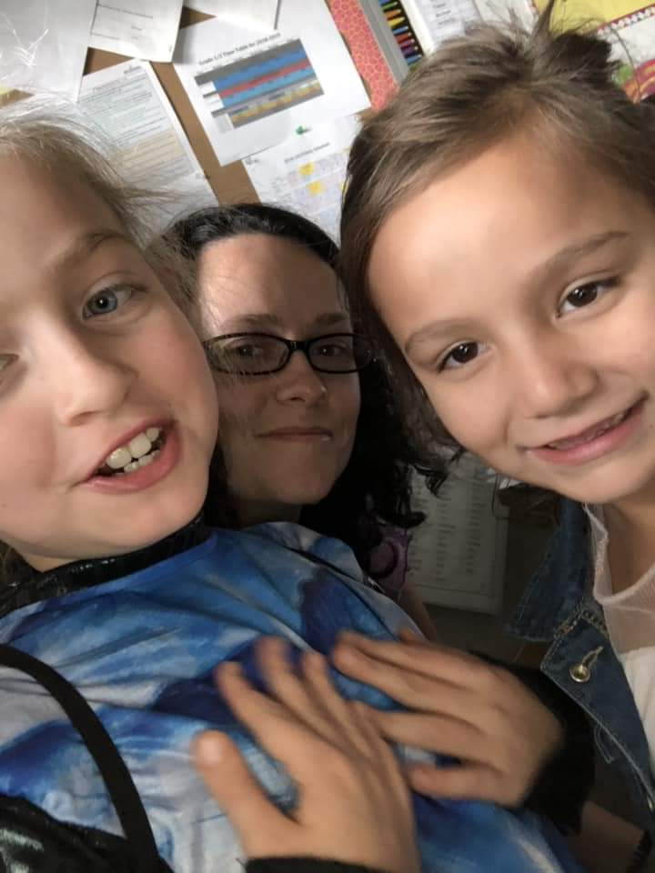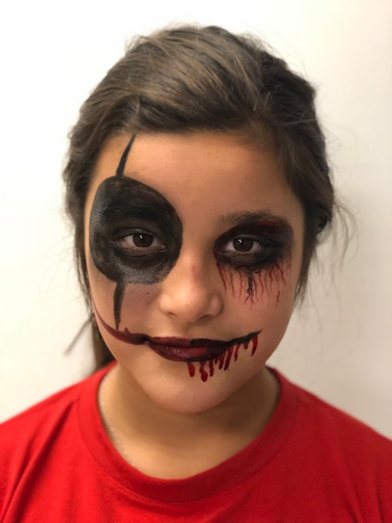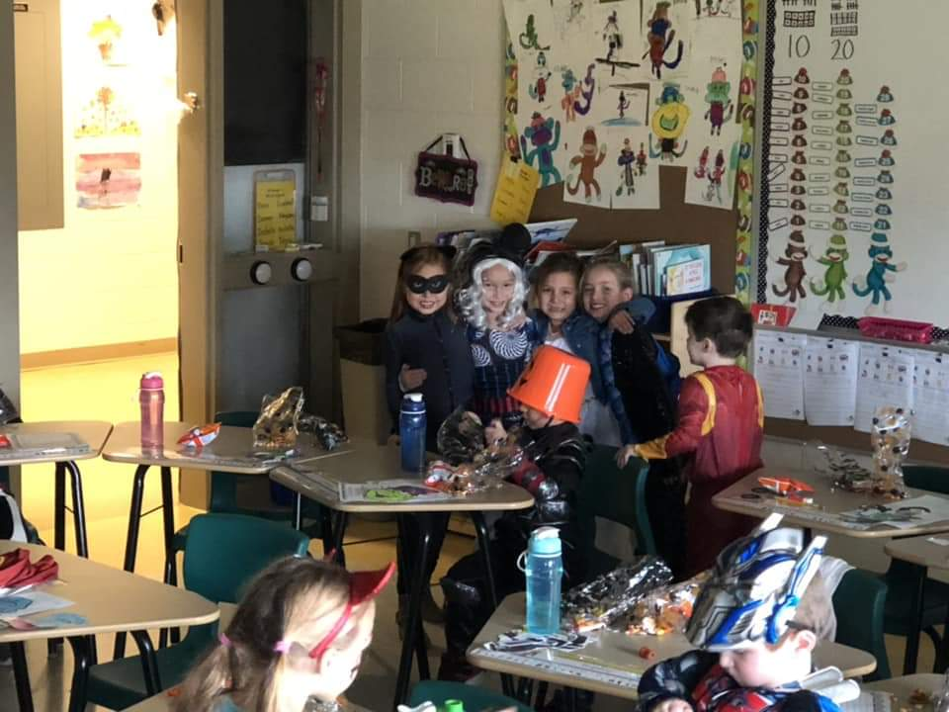

**Dear Parents/Guardians:**

Please read through the newsletter so that you are informed of what is up and coming at our school. Attached is a monthly calendar and our Inclement Weather Notice.

Starting November 14th we will be accepting donations for our School Food Drive.

School Spirit week will be November 19th to 23rd with each day of the week having a different theme. (see calendar for details)

**Save the Date**

Nov.8th Skating AM

Nov.8th Remembrance Day Ceremony 1pm

Nov.9th PD Day (no school for students)

Nov 12th Remembrance Day (All schools closed)

November 14-30th School Food Drive

Nov.19-23rd School Spirit Week (see calendar for details)

Nov.21st Picture retakes

Nov. 30th Parent Teacher Day/Report Cards (no school for students)

Dec.1st Breakfast with Santa

Natoaganeg School

11 Riverview Road East

Eel Ground N.B.

E1V-4G1

Terri Anne Larry, Principal Phone (506) 627-4615

Fax (506) 627-4621

Macintosh HD:Users:Reception:Desktop:remembrance clipart 5.jpg

On November 8th @ 1:00 pm we will be having a Remembrance Day Ceremony. This event is open to the community. There will be light refreshments served.



Keptekewiku’s November 2018

Keptekewiku’s November, 18

It is important that the school has the most up to date phone numbers for our students. If you have changed your phone number or the emergency contacts have changed, please notify the school of these changes.

*Parents of K4 to Grade 2 students:

If your child is taking the bus please remember that the student must be accompanied to and from the bus stop. Even if the bus stop is at the end of your driveway. A parent or guardian must be visible to the bus driver when students are being dropped off at the end of the day. For safety reasons small children should not be left unattended at the bus stops.

**SUCCESSFUL NEWSLETTER DELIVERY BALLOT**

Sign below to indicate that your son/daughter has delivered to you this month’s newsletter. Have your child return this ballot to the ballot box located at the school office by Friday, November 23 2018. At the end of the month a draw will be made for a gift certificate from all the ballots that are returned.

Winner for October: Preston Francis

_______________________________________________________________________________

Parents Signature Child’s name Grade

**Important reminders**

*Students in grades 3 to 8 are required to bring a change of clothes for gym class. All students must have an appropriate pair of indoor shoes that can be left at school.

\***Please ensure your child is dressed appropriately for the weather as it is getting colder and the students go outside for recess in the morning and at lunch.**

**Attendance Policy**

School attendance is taken at 8:30 a.m. Your child is late at 8:31 a.m.

Breakfast is served from 8:05 – 8:25 am. Walkers should arrive as close to 8:05 am as possible (especially if they are eating breakfast)*.*

All students arriving after 8:31 am are considered late and **parents must sign them in at the office** **before going to class**.

 All students being dropped off after 8:31 am must arrive through the main doors of the building.   **Parents please walk your child into school and sign the late form.**

**_____________________________________________________________________________**

**NEKAW NAQSI P+SIN**

**We’re always at school**

**Perfect Attendance Program**

The goal is to promote attendance at school, encourage punctuality, and discourage tardiness. Everyday that a class has perfect attendance they will receive a letter from the phrase **NEKAW NAQSI P+SIN**

The first class to spell out this phrase will receive a pizza party or ice cream party at the end of the month in which they won.

Congratulations to Mr.Canistro’s Grade 8 class for winning a pizza party!!

We would like to express THANK YOU to all parents for recognizing the importance of our attendance policy.

Congratulations to our perfect attendance draw winners for September.

Elementary Winner: Fisher

Middle School Winner: Mariah

- sodales.

**Koqwey kesnu’kuask**

**What’s ailing you?**

**Jukuey tog**

**Come here then.**

**Tami wigin?**

**Where do you live?**

Mi’kmaq Word of the Day

**Mukt asitemiw**

**Don’t talk back to me.**

**Tallukutiog?**

**What are you guys doing?**

Every Monday afterschool

Welcoming new members Grade 4 to 8 girls and boys.

**Wasuekji’jk Beading Club**

**School Food Drive**

Student Council is holding a School Food Drive From November 14th to November 30th.

Some donation ideas are:

Cereal Peanut Butter

Jam Granola Bars

Donations can be brought in by students or dropped off by a Parent/Guardian at the office.

October ended with our Halloween school dance and Haunted House. These events were successful and everyone had fun, thank you to all that came out and supported our school.



Follow us:

Website [www.eelgroundschool.ca](http://www.eelgroundschool.ca)

Join us for Breakfast with Santa Dec.1st

9-11AM

Photos with Santa $5

Breakfast $5 per plate

There will also be a hot chocolate stand

and door prizes.

More information will be posted

as soon as it is available.

Facebook page/group:

Natoaganeg School

and

Natoaganeg Home and School

**Paths® in our School**

Solving problems is hard for children. Solving problems as a group is a skill that our students work on during PATHS**®** time. We learn to identify the problem and write it down. We talk about how we feel about the problem. Then, we brainstorm as many solutions to the problem as we can. We act out the best choices to see how they might work. Next, we choose the best solution and all agree to try it for a few days. We agree to come back and see if we have solved the problem or if it is still happening. If we still have a problem, we try these steps again. We keep trying to solve problems as a group, because we care about each other and work together to be a successful school! You can try this way to solve family problems too. Together is better!

Issue | Date

Lorem Ipsum