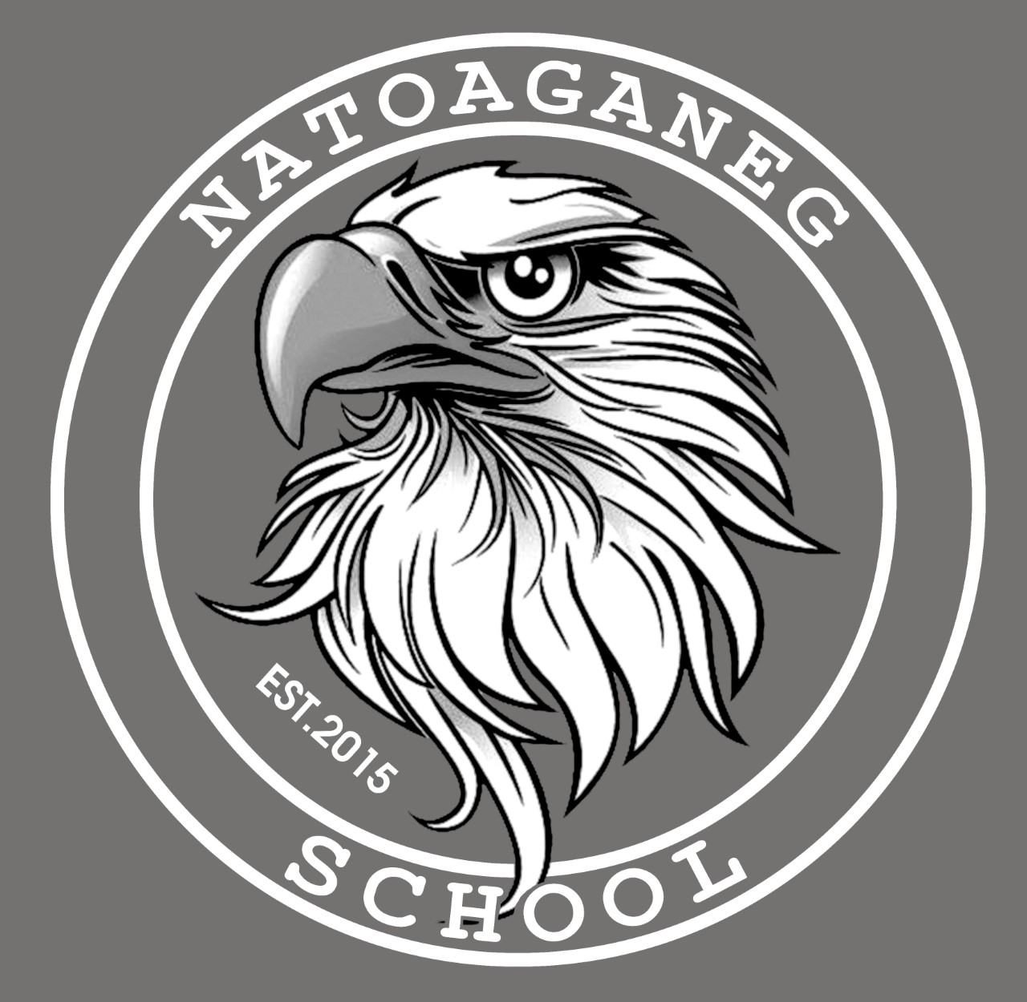

Natoaganeg School

11 Riverview Road East

Eel Ground N.B.

E1V-4G1

Terri Anne Larry, Principal Phone (506) 627-4615

Jenny Sonier, Vice Principal Fax (506) 627-8597

_________________________________________________________________________________________

**Punamujuiku’s 2025 January**

Dear Families and Caregivers:

We hope everyone had an enjoyable and restful holiday season.

A few reminders as we begin the new year:

* Please ensure students come to school dressed appropriately for the weather. Indoor shoes are necessary.
* If your phone number or emergency contacts have changed, please notify the office @ 627-4615.
* **Please use the designated student drop off and pickup area between 7:50am-8:30am & 2:10pm-3:10pm please do not park in the bus loading zone during these times**.

**Skating**

Jan.17 10:50-11:40 Middle school

Jan.24 10:50-11:40 elementary

**Middle school basketball 4:30pm**

Jan.6 vs. BSA - home

Jan.20 vs. Max Aitken – away

Feb.3 vs. BSA – home

Feb.10 vs. Gretna Green – away

Feb.24 Finals

**Elementary Basketball 3:30 pm**

Jan.9 vs. Millerton – home

Jan.23 vs. Esgenoopetitj – away

Feb.6 vs. Napan – away

Feb.13 vs Miramichi Rural - home

# Kelulk Mijipjewey – We Eat Good Food

At Natoaganeg School we do our best to impart a message to the students that promotes healthy foods and healthy food choices.

One way we do this is by providing the children with a healthy and nutritious breakfast, mid-morning snack and lunch each day.

If children bring a snack or lunch from home, they should come prepared with a healthy choice that is low in sugar and sodium.

Some examples of an appropriate snack are:

applesauce, fruits, veggies, cereal bar, granola, yogurt, cheese, crackers.

(8 Grams of sugar or less is considered low)

Sugary and high sodium snacks like chocolate, chips, Gatorade, cookies and cakes should not be brought to school. W`

***

**Mi’kmaq Word of the Day**

Tekik eksitpu’k

(Day - gig eck – sit – boog)

Cold Morning

Ketu metuamkwa’sit sa’ponuk

(get-oo-med-do-am-gwa-sit sa-boh-nook)

Bad weather tomorrow

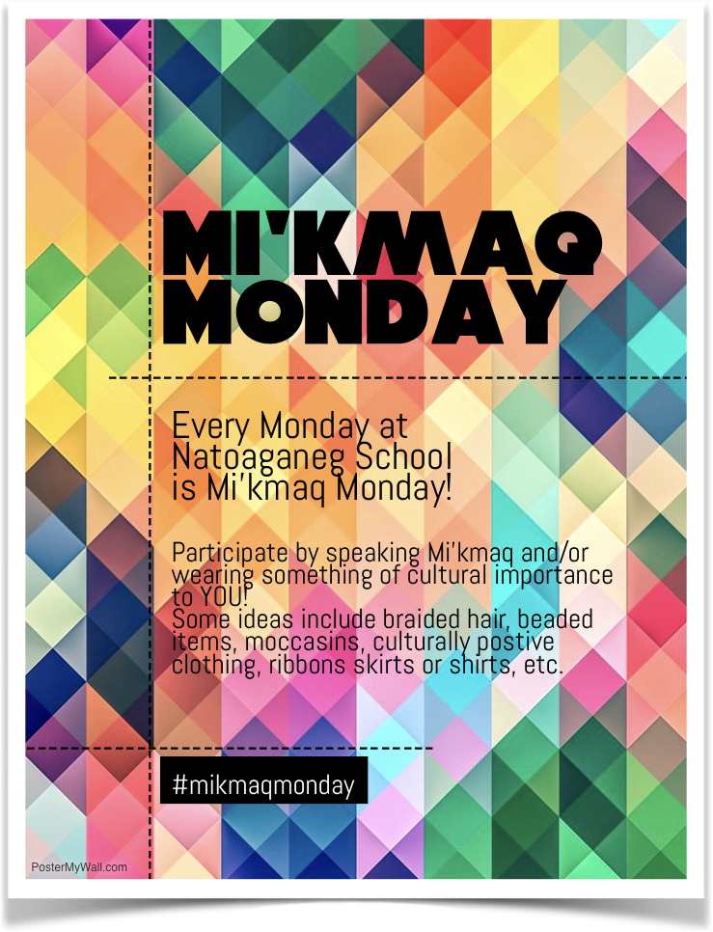

---------------------------------------------------------------------------------------------------------------------------------------------------

**SUCCESSFUL NEWSLETTER DELIVERY BALLOT**

Return this ballot to the box located at the school office by January 24th, 2024. At the end of the month a draw will be made for a gift card from all the signed ballots with the correct answer.

Fill in the blank: ______________________________________________________________snacks like chocolate, chips, Gatorade, cookies and cakes should not be brought to school.

Fill in the blank: Use the designated student drop off and pickup area between ____________ & ____________ please do not park in the bus loading zone during these times

Winner for December: Parker P.

_______________________________________________________________________________________

Child’s name Parents Signature

**The theme for Bell Let's Talk Day 2025 is prioritizing youth mental health**

Since 2011, Canadians and people around the globe have joined in the world’s largest conversation around mental health on Bell Let’s Talk Day. Together we have taken big steps to reduce the stigma around mental health issues, inspire one another to take action, and help create a Canada where everyone can access the mental health support they need. But it is clear more needs to be done. Bell Let’s Talk is a year-round initiative committed to driving positive change by investing in mental health projects and programs and putting a spotlight on mental health through Bell Let’s Talk Day – Canada’s annual day for mental health.

This year, the campaign highlights the progress that has been made and discusses what still needs to be done to support those with mental health challenges, including Canada’s youth who are facing a growing mental health crisis.

**Let’s change this. Take action on Bell Let’s Talk Day and all year long!**

Share your actions using **#BellLetsTalk** and help inspire others to join the movement to create positive change.

You can find resources, learn more about some of the organizations providing mental health supports and services throughout Canada and download the [Bell Let’s Talk toolkit](http://letstalk.bell.ca/en/toolkit/) to begin your own conversation about mental health and create positive change at home, school or in the workplace.

Please join us this Bell Let’s Talk Day by showing your support for all those who live with mental illness and those taking action to help them.

https://letstalk.bell.ca

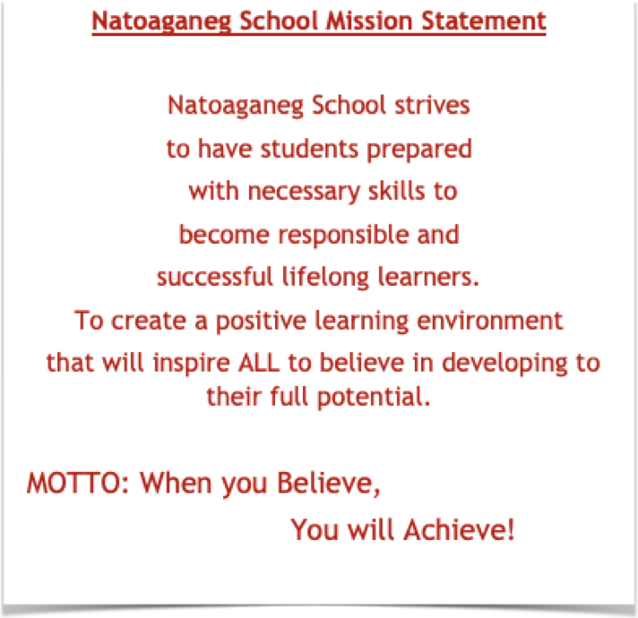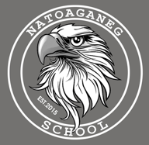

Dates to Remember

Jan.22 Bell Let’s Talk Day

Jan 27 Family Literacy Day

Jan.31 No school for students PD Day

Feb.17th Family Day Holiday