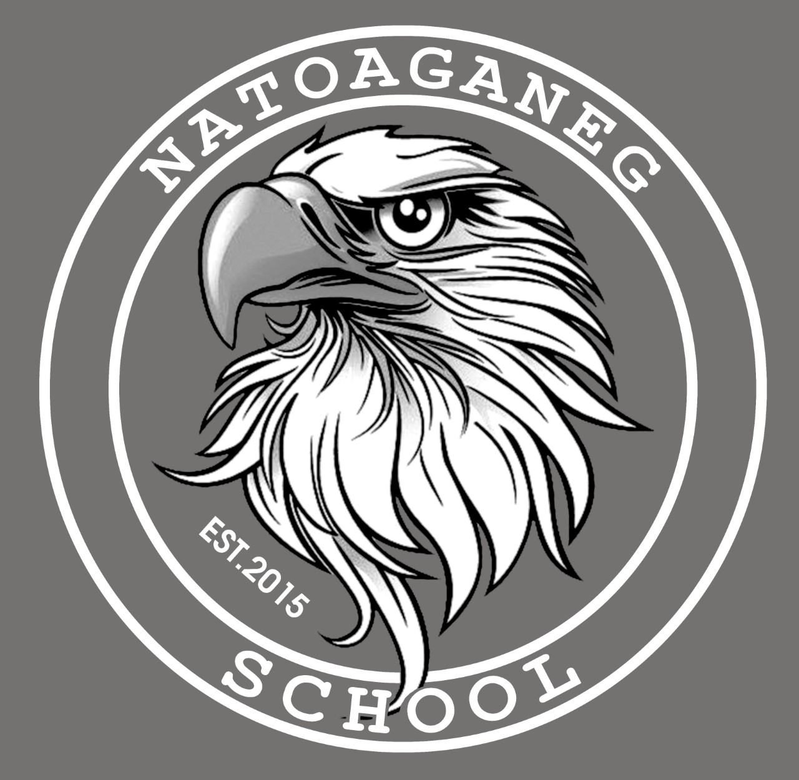

Natoaganeg School

11 Riverview Road East

Eel Ground N.B.

E1V-4G1

Terri Anne Larry, Principal Phone (506) 627-4615

Jenny Sonier, Vice Principal Fax (506) 627-8597

_________________________________________________________________________________________

**Punamujuiku’s 2023 January**

Dear Families and Caregivers:

We hope everyone had an enjoyable and restful Holiday Season.

A few reminders as we begin the new year:

* Please ensure students come to school dressed appropriately for the weather. Indoor shoes are necessary.
* If your phone number or emergency contacts have changed, please notify the office @ 627-4615.
* Use the designated student drop off and pickup area, please do not park in the bus loading zone.
* Being at school on time has an impact on a student’s academic success starting in kindergarten and continuing through high school. Even as children grow older and more independent, families play a key role in making sure students get to school safely every day. It is important to understand that attendance is essential for success in school.  If children do not arrive on time regularly, they miss out on fundamental reading and math skills and the chance to build a habit of good attendance that will carry them through school.



# Kelulk Mijipjewey – We Eat Good Food

**At Natoaganeg School we do our best to impart a message to the students that promotes healthy foods and healthy food choices.**

**One way we do this is by providing the children with a healthy and nutritious breakfast, mid-morning snack and lunch each day.**

**If children bring a snack or lunch from home, they should come prepared with a healthy choice that is low in sugar and sodium.**

**Some examples of an appropriate snack are:**

**applesauce, fruits, veggies, cereal bar, granola, yogurt, cheese, crackers.**

***Sugary snacks like chocolate, juice, chips and cakes should not be brought to school.***



**PATHS® IN OUR SCHOOL**

Parents…do your children ever have difficulty calming down?

You can use the control signals poster as a way to help your child get control of their behavior.

Step 1 is the Red Light: STOP! Take a long, deep breath. Say the problem and how you feel.

Step 2 is the Yellow Light: THINK! What can I do? Would it work?

Step 3 is the Green Light: GO! Try out your solution.

Your child is learning this way to solve problems in the classroom during our PATHS® lessons. Using the same steps at home will help your child remember and follow these steps more often when they have a problem. Helping your child solve their own problems builds self-esteem!



**Mi’kmaq Word of the Day**

Tekik eksitpu’k

(Day - gig eck – sit – boog)

Cold Morning

Ketu metuamkwa’sit sa’ponuk

(get-oo-med-do-am-gwa-sit sa-boh-nook)

Bad weather tomorrow

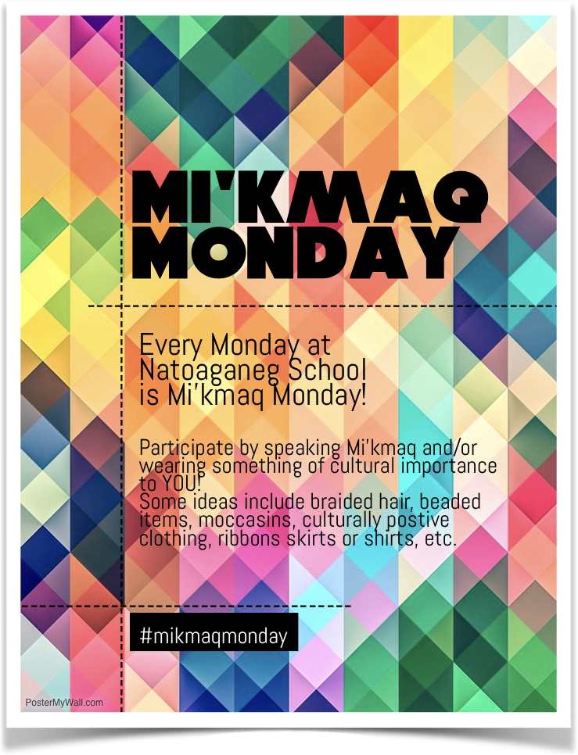

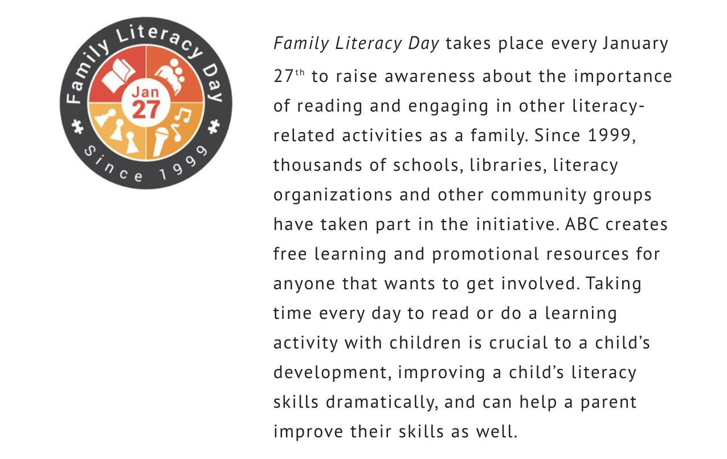

We will be celebrating Family Literacy Day on January 26th along with our PBIS Rewards Day

**____________________________________________________________________________________________**

**SUCCESSFUL NEWSLETTER DELIVERY BALLOT**

Sign below to indicate that your child has delivered to you and you have read this month’s newsletter.

Have your child return this ballot to the ballot box located at the school office by **Friday, January 26th**.

At the end of the month a draw will be made for a gift certificate from all the ballots that are returned.

Winner for December: Amelia C.

_____________________________________________________________________________________________

Parents Signature Child’s Name Grade

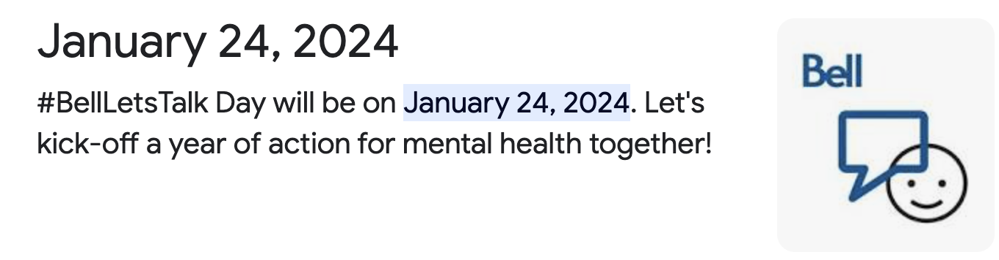

We are joining in and committing to take meaningful action to create positive change.

Since 2011, Canadians and people around the globe have joined in the world’s largest conversation around mental health on Bell Let’s Talk Day. Together we have taken big steps to reduce the stigma around mental health issues, inspire one another to take action, and help create a Canada where everyone can access the mental health support they need. But it is clear more needs to be done.

[Insert information about how your organization, school or community is joining in to help create positive change.]

**Let’s change this. Take action on Bell Let’s Talk Day and all year long!**

This year’s Bell Let’s Talk Day campaign highlights ways we can all create meaningful change and take action by doing one or more of the following:

**C**hoose a mental health organization to learn about or support

**H**elp a friend struggling with their mental health by learning how to support them

**A**sk about how your school, workplace or community is creating change for mental health

**N**urture your own well-being by practicing and learning mental health strategies

**G**et involved in a mental health initiative or organize an event to support mental health

**E**ngage in conversations about mental health to fight stigma

Share your actions using **#BellLetsTalk** and help inspire others to join the movement to create positive change.

We are proud to come together, take action, and help create change for mental health in Canada so that Canadians can access the mental health and addiction supports they need to flourish.

 You can find resources, learn more about some of the organizations providing mental health supports and services throughout Canada and download the [Bell Let’s Talk toolkit](http://letstalk.bell.ca/en/toolkit/) to begin your own conversation about mental health and create positive change at home, school or in the workplace.

Please join us this Bell Let’s Talk Day by showing your support for all those who live with mental illness and those taking action to help them.

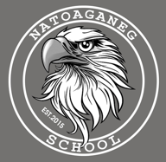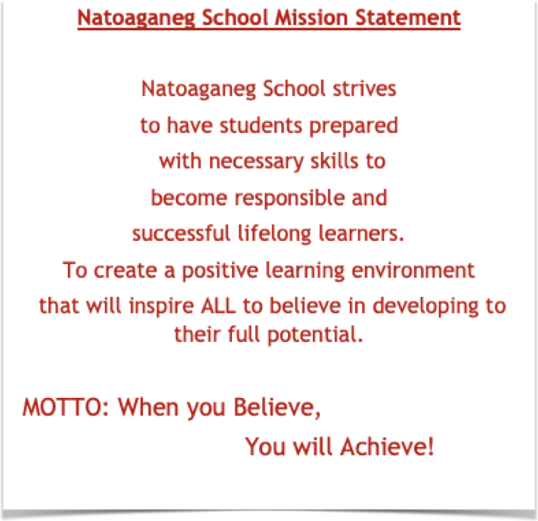

**Dates to Remember**

January 24th Bell Let’s Talk Day

January 26th PBIS Rewards Day/Family literacy day- ½ day for students.

February 19th Family Day Holiday

**Middle School Basketball**

Jan.17 VS Esgenoopetitj (Home)

Jan. 24 VS. Baie Ste Anne (Home)

Jan. 29 VS Nelson (Away)

**Elementary Basketball**

Jan. 11 VS. Napan (Away)

Jan. 25 VS. Millerton (Home)