Kesikewi’kus Newsletter December 2021 | Natoaganeg School  11 Riverview Road East  Eel Ground N.B.  E1V-4G1  Terri Anne Larry, Principal Phone (506) 627-4615  Fax (506) 627-8597
 | Dear Parents/Guardians,  Please note we will be closed for the Holidays at 11:30 am December 17th and will re-open on January 10th.  ____________________  Grade 3-5 Basketball will be starting soon, stay tuned for dates and times.  _____________________  Congratulations to former student Gianna Walker upon receiving the All Start Athletes Award from the Jays Care Foundation for the 20/21 school year. Gianna demonstrated the Girl’s at Bat goals which are: courage, connection, leadership and love of sport.  _____________________  Our PBIS rewards store is looking for donations of gently used or new items that can be used at our next PBIS school store sale. Students will have the opportunity to use points to buy gift for family members. Ideas for donations could be Christmas decorations, puzzles, games, household items etc.  Our next school store sale will be December 10th. | Natoaganeg School will be following the Band Administration  COVID 19 policy  Therefore, please be advised that upon entering Natoaganeg School ALL visitors aged 12 and up must provide Proof of Vaccination along with photo identification.  If you cannot provide the required documentation, you will not be permitted inside the school.

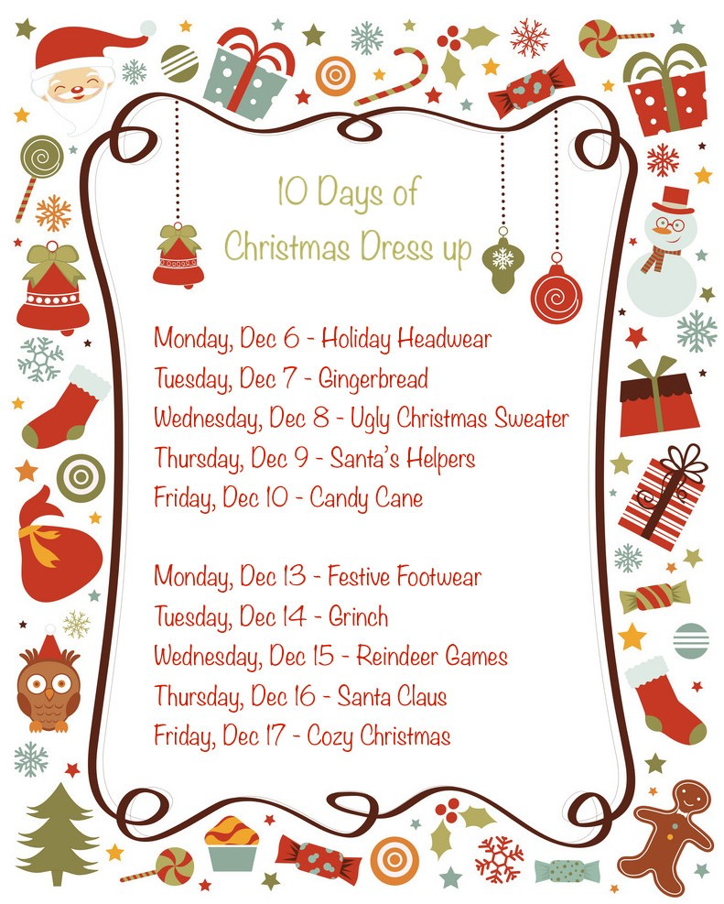
Mi’kmaq word of the day

Kelulk Mijipjewey
We Eat Good Food
At Natoaganeg School we do our best to impart a message to the students that promotes healthy foods and healthy food choices.
One way we do this is by providing the children with a healthy and nutritious breakfast, mid-morning snack and lunch each day.
If children bring a snack or lunch from home, they should come prepared with a healthy choice that is low in sugar and sodium.
Some examples of an appropriate snack are:
applesauce, fruits, veggies, cereal bar, granola, yogurt, cheese, crackers. Sugary snacks like chocolate, juice, chips and cakes should not be brought to school.
Visit our website for photos and recipes! www.eelgroundschool.ca

Weli – Nuelewimk
(well – e new- well -eh – wim- k
Merry Christmas
Wliatew klu’ltn Knuelewimk?
(ool-e-ah dayo gull-ook ten eek-new-elle -eh-wim-k)
Did you have a good Christmas?

Pusu’l Puna’ne!
(Boo-sue-l Boo-nah-nay)
Happy New Year!

School Skating at the Miramichi Civic Centre
All rink dates are from 9- 10am. Bus leaves the school at 8:50am sharp. In the past K4 students were only able to attend if a parent accompanied them. Due to COVID restrictions, the only adults able to attend will be school personnel. The means unfortunately our K4 students will not get skating at the Civic Centre this year.
Dec.13 K5- Grade 3/4
Jan 10th Grade 4/5 - Grade 8
Jan 24th K5 – Grade 3/4
Feb.7th Grade 4/5 – Grade 8
Feb.28th K5 – Grade 3/4
March 21 Grade 4/5 – Grade 8

SUCCESSFUL NEWSLETTER DELIVERY BALLOT
Sign below to indicate that your son/daughter has delivered to you this month’s newsletter. Have your child return this ballot to the ballot box located at the school office by December 15th 2021. At the end of the month a draw will be made for a gift card from all the ballots that are returned.
Winner for November: Aubree
_____________________________________________________________________________________________________________________________________
Parents Signature Child’s name Grade

PATHS® IN OUR SCHOOL
Parents...have you noticed your children complimenting you and others more? Or maybe your child has brought home a compliment list from school? During PATHS® time, one child is chosen to be our PATHS® Kid of the Day. This student helps out with the lesson as a special helper. At the end of the PATHS® lesson, the class gives compliments to the PATHS® Kid of the Day. During this time, we learn how to give a compliment and how to receive a compliment. Giving compliments helps build self- esteem in our students by pointing out their accomplishments and positive things that they do. We notice that the children try harder to make good choices and are proud of their skills!

In the photo: 2020 Youth Leadership Team Nolan, Chase, Rachael, Josh, Blade, Serenity, Gianna, Faith and Brooklyn ensure that everything is ready for School Spirit Days.
 | Student Leadership  This year students in grades 4-8 at Natoaganeg School will take the lead in organizing the activities for the 5 days of School Spirit!  Creating a space that is welcoming, inclusive and lots of fun for all the students and staff is important and necessary. The events will begin Dec.8th and will happen daily for 5 days. The leadership program helps decision making, problem solving and relationship skills. | Mental Health Reminder  Saturday, December 4th 2021 9 am - 11 am  $10 for a takeout breakfast  $5 for a photo with Santa (socially distanced)  Free entry into our door prize draws with a breakfast purchase.  Check out the facebook page for  more information.
 | 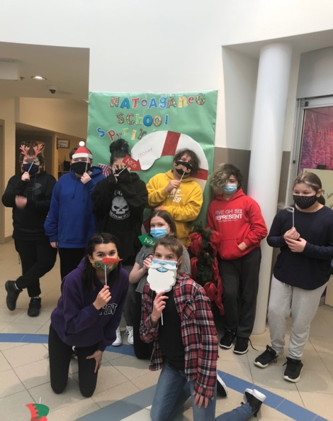
ghy 5
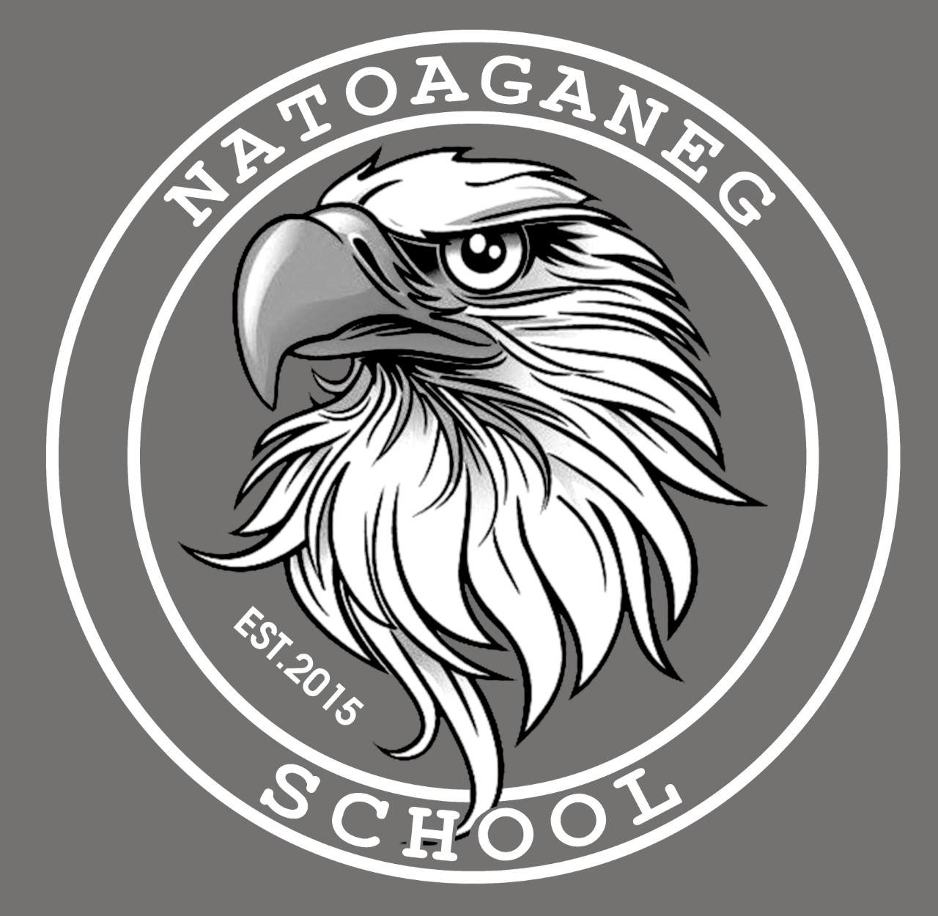
NATOAGANEG SCHOOL MISSION STATEMENT
Natoaganeg School strives
to have students prepared with necessary skills
to become responsible and successful lifelong learners.
To create a positive learning environment that will
inspire ALL to believe in developing to their full potential.
MOTTO: When you Believe,
You will Achieve!

