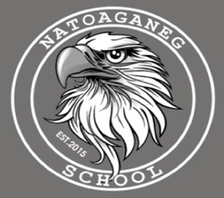
Reminders:

April 8 Early Dismissal 1/2 Day for students

April 26th Half Day for Students

May 16, 17 PD day-No School for students

May 20 Victoria Day -Holiday

Student Pick up and drop off

If you are dropping off a student or picking a student up, please be mindful of the school bus loading zone. For student safety we ask that you use the designated parking area for student drop off/pickup.

Lost and Found
The lost and found is full of clothing that has been left behind by students. Please remind your child to have a look if they are missing any items.

Please ensure that the school has the most up to date phone numbers for your children. If you have changed your phone number or the emergency contacts for a student have changed, please notify the office at 627-4615.
Dear Parents and Caregivers,

Natoaganeg School
11 Riverview Road East
Eel Ground N.B.
E1V 4G1

Terri Anne Larry, Principal Phone (506) 627-4615
Jenny Sonier, Vice Principal Fax (506) 627-8597

Pentamuikus 2024 April
Newsletter

Mi’kmaq word of the day

Maqtawe‘k

Black
Mekwe’k

Red
Wataptek

Yellow
Weli tpamu’k

Very nice color.
Talamu’k?

What color is it?

Kelulk Mijipjewey – We Eat Good Food
At Natoaganeg School we do our best to impart a message to the students that promotes healthy foods and healthy food choices.
One way we do this is by providing the children with a healthy and nutritious breakfast, mid-morning snack and lunch each day.
If children bring a snack or lunch from home, they should come prepared with a healthy choice that is low in sugar and sodium.
Some examples of an appropriate snack are:
applesauce, fruits, veggies, granola, yogurt, cheese, crackers.
Sugary snacks like chocolate, chips and cakes should not be brought to school.
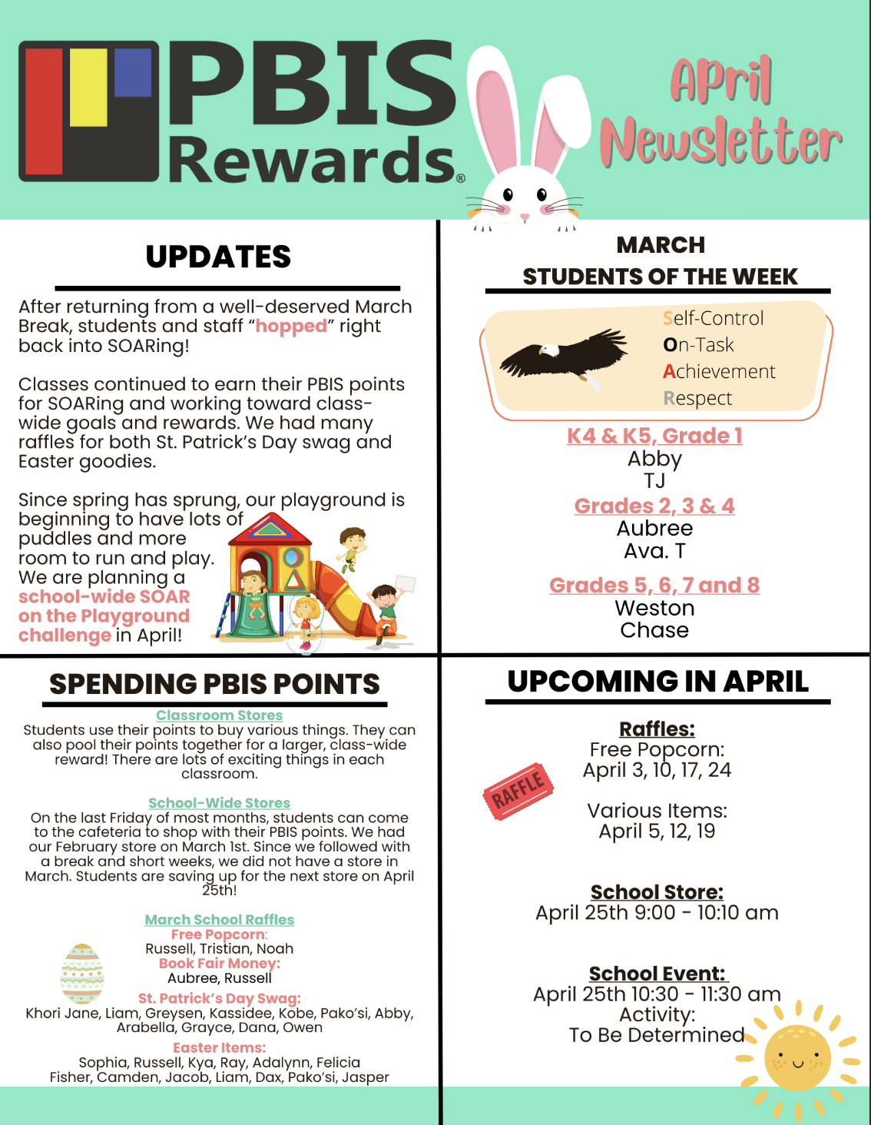
PATHS® IN OUR SCHOOL
Parents…have you noticed your children complimenting you and others more? Or maybe your child has brought home a compliment list from school? During PATHS® time, one child is chosen to be our PATHS® Kid of the Day. This student helps out with the lesson as a special helper. At the end of the PATHS® lesson, the class gives compliments to the PATHS® Kid of the Day. During this time, we learn how to give a compliment and how to receive a compliment. Giving compliments helps build self-esteem in our students by pointing out their accomplishments and positive things that they do. We notice that the children try harder to make good choices and are proud of their skills!

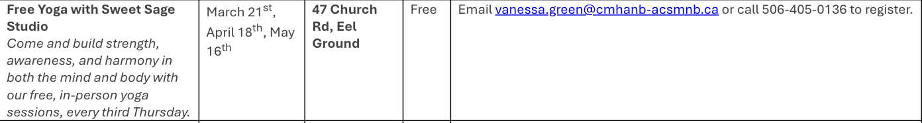

SUCCESSFUL NEWSLETTER DELIVERY BALLOT

Sign below to indicate that your son/daughter has delivered to you this month’s newsletter. Have your child return this ballot to the ballot box located at the school office by Friday, April 19th 2024
At the end of the month a draw will be made for a gift card from all the ballots that are returned.
March Winner: Arabella S

________________________________________________________________________________________________
Parents Signature Grade Childs name

Some of our students have been participating in the school Music Wellness program under the guidance of songwriter and musician Terry Whalen.
This weekly program provides students with the opportunity to use music to express
and embrace their talent and creativity in a safe space.

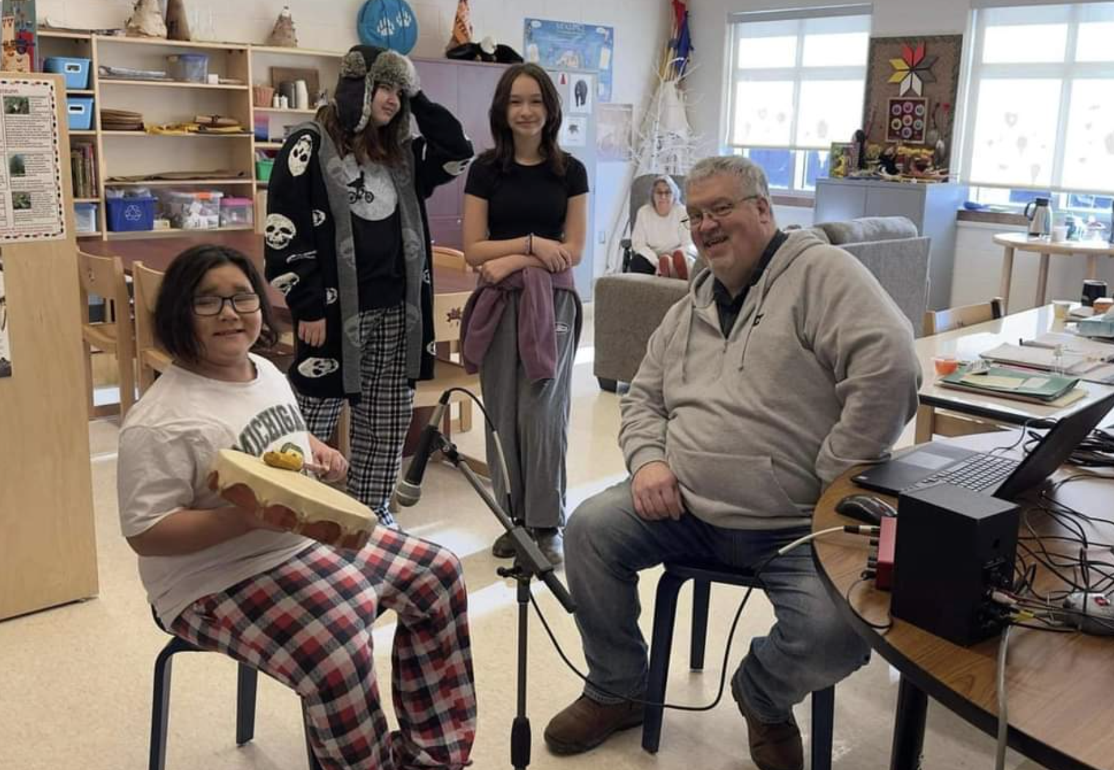

Natoaganeg School Mission Statement

Natoaganeg School strives
to have students prepared
with necessary skills to
become responsible and
successful lifelong learners.
To create a positive learning environment
that will inspire ALL to believe in developing to their full potential.

MOTTO: When you Believe,
You will Achieve!

Schedule

Breakfast served 8:10 – 8:40am
Morning announcements 8:45 am
Classes begin 8:50 am

Lunch
K4-Gr3/4 11:40 – 12:00pm
Gr.5-8 12:00 – 12:20pm

Dismissal
K4-Gr. 2 2:00 pm
Gr.3-8 2:30 pm

Attendance Policy
School attendance is taken at 8:45am.
3 Lates = 1 Absent

Volleyball
April 4 NSER @Natoaganeg
April 11 Natoaganeg @ Blackville
April 18 MAA2@Natoaganeg
April 25 Natoaganeg @ NSER
*all games start at 4:30pm

